**LAB #06:**

**Name: Mohkum din__________________ Reg #: _f2025-1028_________________ Marks:**

# Lab6:Switch case, nested if, if else if

## Q1: Write a program that prompts the user to input three numbers and then displays them in ascending order (from smallest to largest). CLO1, CLO2

|  |
| --- |
| #include<iostream>  Using name space std;  int main(){  int n1,n2,n3;  cout <<”enter first number” << endl;  cin >> n1;  cout <<”enter 2nd number” << endl;  cin >> n2;  cout <<”enter 3rd number” << endl;  cin >> n3;  if (n1 <= n2 && n1 <= n3) {  smallest = n1;  if (n2 <= n3) {  middle = n2;  largest = n3;  } else {  middle = n3;  largest = n2;  }  }  else if (n2 <= n1 && n2 <= n3) {  smallest = n2;  if (n1 <= n3) {  middle = n1;  largest = n3;  } else {  middle = n3;  largest = n1;  }  }  else {  smallest = n3;  if (n1 <= n2) {  middle = n1;  largest = n2;  } else {  middle = n2;  largest = n1;  }  }  cout << "Numbers in ascending order: " << smallest << ", " << middle << ","<<largest << endl;  return 0;  } |

## Q2: What is the output of the following program: CLO1, CLO2

|  |
| --- |
| Write output here: 7 |

#include <iostream>  
using namespace std;  
  
int main() {  
 int b = 6, c = 5;  
 if (b++ >= 7 && ++c == 5)  
 b += c;  
 else  
 cout << b- - << endl;  
 return 0;  
}

## Q3: What is the output of the following program: CLO1, CLO2

|  |
| --- |
| Write output here:  5o 100  50 100 |

## Q4: What is the output of the following program: CLO1, CLO2

|  |
| --- |
| Write output here:  n= 3 |

#include <iostream>  
using namespace std;  
int main() {  
 int n = 0;  
 if ('A' == 'a')  
 n = 1;  
 else if ('A' > 'a')  
 n = 2;  
 else  
 n = 3;  
 cout << n << endl;  
 return 0;  
}

## Q5: Evaluate the following: CLO1, CLO2

|  |  |  |
| --- | --- | --- |
| **Sr** | **Expression** | **Result** |
| A | 6 <= 6) && (5 < 3) | false |
| B | (6 <= 6) || (5 < 3) | true |
| C | (5 != 6) | true |
| D | (5 < 3) && (6 <= 6) || (5 !=6) | true |
| E | (5 < 3) && ((6 <= 6) || (5 !=6)) | false |
| F | !((5 < 3) && ((6 <= 6) || (5 !=6))) | true |
| G | !(12 > 25) && !(18 < 17) | true |

## Q6: Speed of Sound in Gases: (First solve Q6 then solve Q5) CLO1, CLO2

|  |  |
| --- | --- |
| Gas | Speed (m/s) |
| Carbon dioxide | 258.0 |
| Air | 331.5 |
| Helium | 972.0 |
| Hydrogen | 1,270.0 |

Write a program that displays a menu so the user can select one of the gases listed above.  
After the choice, the user enters the **time (in seconds)** it took for the sound to travel from the source to the receiver.

The program should compute and display the **distance** using:

$$\text{Distance}=\text{Speed}×\text{Time}$$

**Input Validation**

* Only accept valid menu choices.
* Time must be **between 0 and 30 seconds** (inclusive).

**Write code in if else if and switch case.**

|  |
| --- |
| #include <iostream>  using namespace std;  int main() {  int choice;  float time, speed, distance;  cout << "Select a gas:” << endl;  cout << "Carbon dioxide << endl;  cout << "Air” << endl;  cout << "Helium” << endl;  cout << "Hydrogen\n";<< endl;  cout << "Enter your choice (1-4): ";  cin >> choice;  if (choice >= 1 && choice <= 4) {  cout << "Enter time (in seconds, 0–30): ";  cin >> time;  if (time >= 0 && time <= 30) {  if (choice == 1)  speed = 258.0;  else if (choice == 2)  speed = 331.5;  else if (choice == 3)  speed = 972.0;  else  speed = 1270.0;  distance = speed * time;  cout << "Distance traveled by sound: " << distance << " meters" <<endl;  }  else {  cout << "Invalid time." <<endl;  }  }  else {  cout << "Invalid menu choice! " <<endl;  }  return 0;  } |

Switch case code:

|  |
| --- |
| #include <iostream>  using namespace std;  int main() {  int choice;  float time, speed, distance;  cout << "Select a gas:" << endl;  cout << " Carbon dioxide” << endl;  cout << "Air” << endl;  cout << " Helium” << endl;  cout << “ Hydrogen” << endl;  cout << "Enter your choice (1-4): " << endl;  cin >> choice;  if (choice < 1 || choice > 4) {  cout << "Invalid menu choice" <<endl;  return 0;  }  cout << "Enter time (in seconds, 0–30): ";  cin >> time;  if (time < 0 || time > 30) {  cout << "Invalid time” <<endl;  return 0;  }  switch (choice) {  case 1:  speed = 258.0;  break;  case 2:  speed = 331.5;  break;  case 3:  speed = 972.0;  break;  case 4:  speed = 1270.0;  break;  }  distance = speed * time;  cout << "Distance traveled by sound: " << distance << " meters" << endl;  return 0;  } |

## Q7: Speed of Sound in Different Mediums CLO1, CLO2

|  |  |
| --- | --- |
| **Medium** | **Speed** |
| Air | 1,100 feet per second |
| Water | 4,900 feet per second |
| Steel | 16,400 feet per second |

Write a program that displays a menu for the user to select one of three mediums: **Air**, **Water**, or **Steel**. After the user makes a selection, ask for the **distance** (in feet) a sound wave will travel in that medium. The program should then calculate and display the **time** required for sound to travel that distance. Use the formula:

$$\text{Time}=\frac{\text{Distance}}{\text{Speed}}$$

Round the result to **four decimal places**.

**Input Validation**

* The user must select a **valid menu option**.
* The distance entered must be **greater than or equal to 0**.

|  |
| --- |
| #solution code in if else if:  #include <iostream> #include <iomanip> using namespace std;  int main() {  int choice;  double distance, time;  const double air = 1100, water = 4900, steel = 16400;  cout << "Speed of Sound Calculator\n";  cout << "1. Air\n";  cout << "2. Water\n";  cout << "3. Steel\n";  cout << "Enter your choice (1-3): ";  cin >> choice;  if (choice >= 1 && choice <= 3) {  cout << "Enter distance (feet): ";  cin >> distance;   if (distance < 0) {  cout << "Error: Distance cannot be negative.";  return 0;  }  if (choice == 1)  time = distance / air;  else if (choice == 2)  time = distance / water;  else  time = distance / steel;  cout << fixed << setprecision(4);  cout << "Time taken: " << time << " seconds\n";  }  else {  cout << "Invalid input! Please choose 1, 2, or 3.";  }  return 0; } |

The above Speed of Sound in Different Mediums program given code in if else if, please modify above code in switch case.

|  |
| --- |
| #include <iostream>  using namespace std;  int main() {  int choice;  float distance, time;  int air = 1100, water = 4900, steel = 16400;  cout << "Speed of Sound Calculator" << endl;  cout << "1. Air” << endl;  cout << "2. Water” <<endl;  cout << "3. Steel" <<endl;  cout << "Enter your choice (1-3): ";  cin >> choice;  if (choice < 1 || choice > 3) {  cout << "Invalid input";  return 0;  }  cout << "Enter distance (feet): ";  cin >> distance;  if (distance < 0) {  cout << "Error";  return 0;  }  switch (choice) {  case 1:  time = distance / air;  break;  case 2:  time = distance / water;  break;  case 3:  time = distance / steel;  break;  default:  cout << "Invalid choice!";  return 0;  }  cout << fixed << setprecision(4);  cout << "Time taken: " << time << " seconds" <<endl;  return 0;  } |

## Q8: Write code from flowchart. CLO1, CLO2

You are given a flowchart that compares three numbers and determines the **largest among them**.

Using the logic shown in the given flowchart, write a **C++ program using nested if statements** to input three numbers and display the **largest number**.

**Note:** You must follow the flowchart structure and use nested if conditions (not if-else-if or max functions).

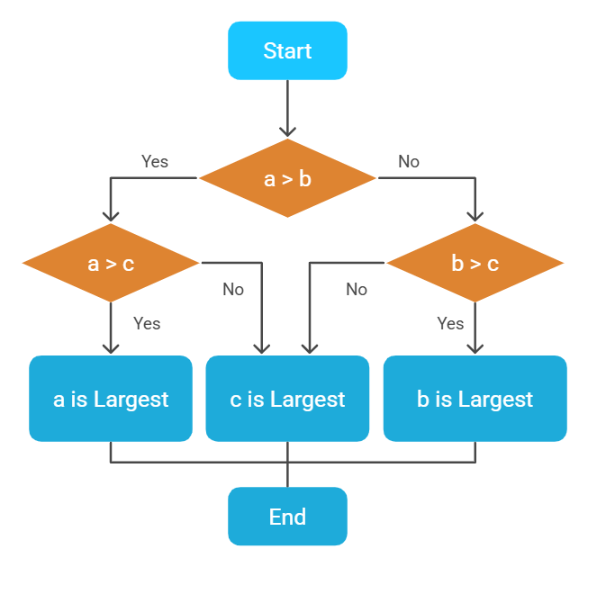

|  |
| --- |
| #include <iostream>  using namespace std;  int main() {  float num1, num2, num3, largest;  cout << "Enter three numbers: ";  cin >> num1 >> num2 >> num3;  if (num1 > num2) {  if (num1 > num3)  largest = num1;  else  largest = num3;  }  else {  if (num2 > num3)  largest = num2;  else  largest = num3;  }  cout << "The largest number is: " << largest << endl;  return 0;  } |